COME AND KUCHINATE WITH ME
it behooves us to consider our own past while we consider what to do with those drifting souls.
BY PAMELA PELED JULY 12, 2018 19:48

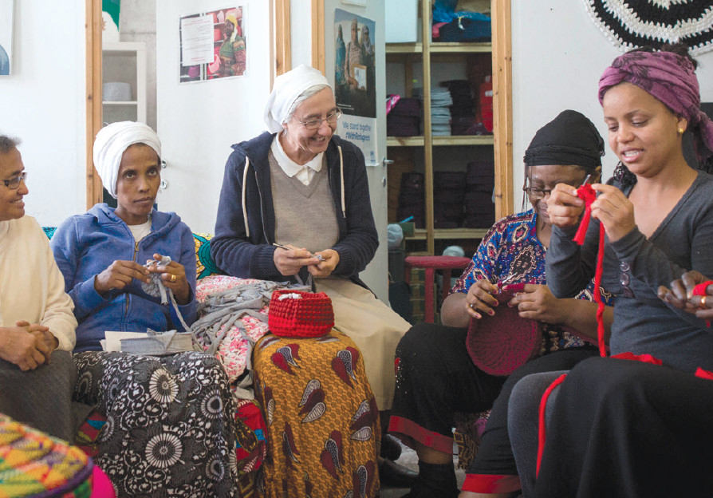

KUCHINATE, ‘CROCHETING’ in Tigrinya, the language of Eritrea, is a collective of African asylum-seeking women who crochet colorful baskets and carpets in a studio pulsing with children, hot food, volunteers and nuns. (photo credit: MIRIAM ALSTER)

Over 400 years ago, when Shakespeare wrote his “Jewish” play, nobody in England had actually seen a Jew. They had all been kicked out, or murdered, by Edward I, in 1290, 300 years before The Merchant of Venice hit the Globe Theater. Yet Elizabethans still loathed Jews with a passion.

While I was discussing this with my students some years ago, one raised her hand. She related a crazy story: In the 1970s she was a young freshman at a provincial university in England. Each night a different boy asked her out for a drink; each boy subsequently leaned across the pub table and stroked her hair. Eventually, one of the dates explained. The students had heard that she was Jewish; the campus challenge was who would find her horns first.

As Jews, we know a bit about prejudice and xenophobia; as Israelis, the issue of our own black refugees cuts very close to home. Are they bringing crime and chaos to our country’s streets, and should we chuck them out forthwith? Or do we especially have the moral imperative to remember the stranger within our midst?

For those of us who grew up under apartheid, the discussion is even more fraught. Images of poverty and privation are etched indelibly in our cerebral cortex, complicating the arguments raging in Tel Aviv today. Half a century down the line, I vividly remember throwing cooked chickens and day-old cheese sandwiches out of our train window, en route to Habonim camp. Our mothers (and maids) had piled food for weeks into hampers for the trip; after the first meal, we ate in the dining car. So we doled out the leftovers to crowds of hungry pickaninnies on the platforms of dusty Karoo towns, their teeth flashing whitely at the unexpected bounty.

It took just one step into a drab south Tel Aviv street to catapult me back into the awful mixed feelings that Africa elicits. So beautiful, so majestic, so calm and so sad. And now Africa has come to Israel, with approximately 40,000 refugees still here. And among the weakest and most vulnerable of them are the 12,200 Eritrean women, many of them single mothers. Some of these women are ill, some have sick children; many of them are destitute and lonely, and lost.

But, as Maria told Captain Von Trapp: When God closes a window, He opens a door. Enter Diddy Mymin Kahn, surely God’s door in a dilapidated tenement building on the appropriately named Mount Zion Avenue. Buzzed in through an iron gate, one climbs up through an unprepossessing stairwell to enter Kahn’s kingdom of crocheting heaven. And I don’t say that lightly.

Kuchinate, “crocheting” in Tigrinya, the language of Eritrea, is a collective of African asylum-seeking women who crochet colorful baskets and carpets in a studio pulsing with children and hot food and volunteers and nuns. The workers, escaping their drab and lonely living quarters for some healing hours of community and productive labor, earn a basic salary. Extra cash comes from the sale of the products, traditional coffee ceremonies, and workshops for the public.

Beautiful Kahn, clinical psychologist and an electrifying 53-year-old mother of three, was born in Israel, grew up in South Africa and lived for years in London. In 2009, back in Israel, she tried to give therapy in a shelter funded by the United Nations High Commissioner Project for refugees, run by the African Refugee Development Center

“I was working in a pilot project to offer assistance to women who survived torture camps in the Sinai; women who had been raped and tortured,” recalls Kahn. “They had no idea how to react to therapy; there was not even a word in their lexicon for therapy. It was culturally alien for them to talk about negative events in their past to a stranger.” A survivor of a torture camp in Sinai explained: “Thinking and thinking – you can spoil your mind.” What they needed, Kahn understood, was food for that day, a job, somewhere for their kids to sleep.

It was at this point that Kahn met Sister Aziza Kidane, an Eritrean nun and nurse, and Natasha Miller Goodman, a South African immigrant artist, who were both involved in the shelter. In 2011 they started Kuchinate, a nonprofit, with five women on their books. Today over 200 women weave and crochet and chat and heal in the center, 70 of whom take home a regular paycheck.

Just imagine handling heart disease and cancer, or kids with disabilities, on top of hunger and fear of what tomorrow holds. Then suddenly you find yourself in a secure space, crocheting with respected artists such as Gil Yefman (a crocheting man!), producing vivid life-size baskets, containing the collective stories of the refugees, and being exhibited in the Haifa Museum of Art and the Feldman Gallery in New York City. It sounds too fantastical to be real. Visit the “Women and Genocide” exhibition and see for yourself how dreams can come true.

Not that surviving genocide is remotely dreamy. The ensuing trauma is enough to gut anyone for a lifetime, but the problems of refugees never seem to end and must appear totally insurmountable to vulnerable survivor women who land up in Tel Aviv. Their status is uncertain and, according to Kahn, even the few benefits doled out come with nightmarish bureaucracy.

The best solution, and the one most refugees pray for, is to be resettled in a friendly country such as the US or Sweden or Canada. Kahn works with the UNHCR to get her women resettled; so far, dozens have found new homes.

In the meantime Kuchinate provides bicultural therapy to help deal with trauma – a “goodness of fit between what they need and what we can offer,” explains Kahn. And a network of mahazut – Israeli “friends” who ferry mothers to hospitals to visit sick children, or help with English or legal problems – provides some much needed support.

In a stark juxtaposition, Swedish photographer Miriam Alster followed the Kuchinate women for three months and exhibited her photos alongside those of famous Swedish photographer Anna Rivkin of Jewish refugees working in a toy factory in Sweden during World War II.

Israel cannot, of course, cater to all the refugees of Africa. And government policies have efficiently ensured that no more are entering our country. Yet it behooves us to consider our own past while we consider what to do with those drifting souls who have already made it to our shores. Don’t you think?

